Inclusion and Diversity Policy

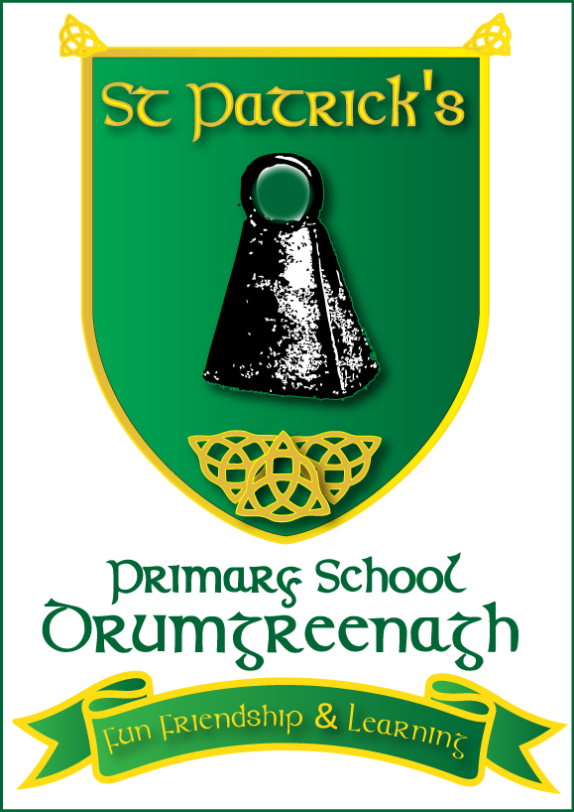

Policy Adopted: March 2020
Next Review Date: 2023

Signed:_______________________
(Chair of Governors)

Date:________________________

In St. Patrick’s, we are firmly committed to providing a quality education service which is inclusive for everyone both within the school community and across the surrounding district which we serve.

The child is at the heart of our school and the wider Catholic faith community. As a school, we aim to provide a high standard of child-centred education in a safe, supportive, learning environment, where respect and Catholic values are promoted.

Our school motto is “Fun, Friendship and Learning”

Our inclusion and diversity policy aims to:

- To create an environment where a wide variety of nationalities and cultures are welcomed and included
- To promote an ethos of security for children to grow and develop commensurate with their
particular needs and capabilities
- To provide opportunities for the sharing of a variety of cultures
- To allow children to feel secure within their own identity as well as appreciating the diversity of cultures within our school and the wider communities of Barnmeen, Drumgath and Rathfriland
- To provide support for children for whom English is not their home language: English may become the first language as it is the one they begin to use every day but it isn’t the home language

Meeting the aims

Within our School we have children of all abilities, including those with Special Educational Needs, and children for whom English is not the home language. Children are encouraged to develop an awareness that there are many different cultures, faiths, languages and lifestyles.
We all have different likes and dislikes and these preferences must be respected.
We aim to teach our children that difference is not something to fear and inculcate in children a natural curiosity, respect for others, empathy and an ability to communicate in a respectful manner.

The role of staff members

- To have an awareness of how different cultures and backgrounds will create different experiences
- To have a positive attitude where linguistic diversity is valued and opportunities are created for children to use their home language in play
- Staff must not make assumptions about the way families from other countries raise their children
- To ensure that Peer groups are given clear and specific information about the child – where he is from, language and culture
- To support children for whom English is not the home language
- To facilitate newcomer children in class groupings where they will have the maximum level of initial and ongoing support
- To identify through informal observation, the level of communication and understanding of each individual child in order to build up an individual pupil profile - using the EAL CEFR pupil record
- To enhance language through learning opportunities offering a wide variety of experiences/materials
- To work as a team to meet each individual child’s needs through the planned activities
- To report appropriately to parents/guardians. (Interpreting services may be required
- To ensure an abundance of positive affirmation and non-verbal communication, being careful to explain things simply to ensure comprehension

We believe that:

- A child’s home language is an integral part of their identity, background and community
- Encouraging children to use their home language gives a sense of pride and self-esteem (The home language is the foundation on which the second language is built, and both languages can be built together)
- Bilingualism has many benefits for learning
- English DOES NOT REPLACE the home language
- Children will benefit from an intercultural setting – it will allow them to understand the growing multi-cultural community in which they live
- Children may find it difficult to understand that children who similar to them speak a different language – everyone will benefit from learning about other languages

We involve parents/guardians by -

- Understanding that the child’s parents/guardians are the prime educators and valuing their contributions
- Explaining the local education system to Newcomer parents.
- Sharing information translated documents when appropriate
- Involving parents/guardians in making intercultural resources – labels, name-printing etc.

How we create a positive atmosphere for inclusion and diversity

- Welcome posters and booklets are made available in a range of languages as appropriate to support the transition of children and parents into school where required
- Intercultural home corners, dressing up boxes, story types, cultural artefacts will be accessible for all children
- Home languages are valued by encouraging children to use these while engaged in activities
- Festivals and different cultural traditions are discussed and celebrated throughout the year.

The Global Dimension in our curriculum

In St Patrick’s children are offered a variety of experiences that encourage and support them to begin to make connections between different parts of their life experience. They become aware of their relationships with others and of the different communities of which they are members for example, family, school, parish, sporting etc. They begin to develop awareness of diversity in people, places, cultures, languages and religions. They begin to understand fairness, the need to care for other people and the environment, and to be sensitive to the needs and views of others. Staff have been involved in Newcomer Training.

Teaching young learners about the global dimension
- Helps them to adapt to an ever changing world
- Helps them fulfil their potential as good world citizens by contributing to the good of a wider society

Global Education in St. Patrick’s focuses on multi differences, though overlapping levels, from local to global. It implies also a holistic view of education, with a concern for children’s emotions, relationships and a sense of personal identity as well as with information and knowledge
Our Global Dimension is therefore an integral part of education in St. Patrick’s, helping our children make sense of the world around them and giving them opportunities to connect to a wider world through their school experiences e.g. music, food, sport, media, etc. It is not restricted to learning geography or where places are – it is about making connections between the local and the global, understanding that no-one exists in isolation – we are all connected

OUR CURRICULUM aims to –
“Promote children’s spiritual, moral, social and cultural development and prepare ALL our children for the opportunities, responsibilities and experiences of life.”
It involves EIGHT KEY CONCEPTS

Human Rights
Global Citizenship
Interdependence
Social Justice
Conflict Resolution
Values & Perceptions
Sustainable Development
Diversity

Our curriculum includes a built-in global dimension as it is in the Early the Foundation Stage/ Key Stage One and Two that our children begin to develop the knowledge, skills and attitudes required to understand the world and to develop as good global citizens of the future.
We therefore provide opportunities for them to begin to understand the Eight Key Concepts of Global Dimension thus offering them the opportunity to develop in: -

Knowledge and Understanding
- Social justice and equality
- Diversity
- Interdependence
- Peace and conflict

Skills
- Critical thinking
- Ability to argue effectively
- Ability to challenge injustice and inequality
- Respect for people and things
- Co-operation and conflict resolution

Values and Attitudes
- Sense of identity and self-esteem
- Empathy
- Commitment to social justice and equity
- Value and respect for diversity
- Concern for the environment and commitment to the sustainable development
- Belief that people can make a difference

Throughout Foundation Stage and KS1, as educators we focus on the development of self-esteem, communication and co-operation skills thus providing foundations for the future development of the key concepts of the global dimension.
Our children become aware of their connections with different people and groups and how these inter-relate e.g. home and school setting. Through high quality and varied provision of learning opportunities, the children will develop a greater awareness of the diversity of peoples, places, cultures, languages and religions. As their self-esteem is fostered, the children will begin to understand fairness, the need to care for others and the environment, while at the same time learning how to be sensitive to the needs and views of others.

Our curriculum fosters an interactive and experiential approach to learning with activities that link across the different areas of learning. The Early Years’ curriculum provides our young learners with an environment that is relevant, enjoyable and challenging; an environment that is outward looking, encouraging our children to understand themselves, their wider community and the interdependence of the world. It will subsequently enrich learning experiences and ensure that every child succeeds. Our children will be prepared to ‘think globally, act locally’ and to be active citizens.

Personal, Social and Emotional Development

Our children will seek to:
- Develop an understanding of different feelings that affect themselves and others in different situations, through looking at pictures and photographs and sharing stories (diversity, interdependence, conflict resolution)
- Consider the needs and wants that everyone has, including water, food, love, security by using images from around the world (Human Rights and the UN, Trócaire, Convention on the Rights of the Child, Article 12: ‘Children have the right to say what they think should happen when adults make decisions that affect them, and to have their own opinions taken into account’ – UNICEF, Children’s Rights and Responsibilities leaflet).
- Learn about rights and wrongs through listening and discussing stories from around the world. They consider the needs of others and how we can help one another (values and perceptions)
- Participate in activities from different cultures, including games, stories and food. They will reflect on similarities and differences that relate to themselves and different cultures and religious traditions (diversity, values and perceptions)
- Through using stories, create opportunities to discuss the issue of bullying and fairness (conflict resolution / social justice)
- Consider ways in which they can reduce, re-use and recycle resources in their setting, at home and in the wider environment. These ideas are
    - a) introduced through well planned topics and themes and through sharing resources (sustainable development)
    - b) supported by the contributions of both the School Council and Eco Committee at whole school level
will provide opportunities to develop their understanding of other places through sharing experiences

Communication, Language and Literacy

Our children:
- Are provided with opportunities to share stories etc from around the world. They discuss the issues and topics and so help to develop their values and perceptions and understanding of similarities and differences (values and perceptions)
- Develop positive, anti-discriminatory language through the examples set by practitioners (diversity, values and perceptions)
- Have opportunities to get to know people from ethnic minorities
- Hear a range of accents, dialects, languages, and know that these are valued. They have the opportunity to see different scripts and use dual-language books (diversity, values and perceptions)
- Learn about the feelings of others and how to resolve conflict in their setting
- Through stories, photographs, puppets and persona dolls they develop understanding and skills relating conflict resolution. They learn how different behaviours affect others and that the outcomes of situations may vary (conflict resolution)
- Gain self-esteem by having the opportunity to express their opinions in a way that will effect change in the setting (global citizenship, human rights)

Mathematical Development

Our children:

- Have opportunities to use objects from different countries to develop their mathematical concepts (diversity)
- Look at photographs and drawings from different countries to see how other cultures use number, shape and pattern (diversity)
- The different cultural experiences of young learners are shared to develop their understanding of number (diversity)

World Around Us

Our children:

- Use photographs, books and artefacts from around the world to think about and discuss similarities and differences between people and places, locally and globally (diversity, values and perceptions)
- Learn about various cultures and religions through stories, poetry, music, dance and food (diversity)
- Develop an understanding of others through role play, using clothes, cooking utensils, toys and artefacts from different cultures (diversity, values and perceptions)
- Are encouraged to use ICT to find where their peers are from, places they have visited, or have seen on television/online. They discuss where their foods have come from – do they buy locally or globally (interdependence, social justice)?
- Have opportunities to learn about sustainable development, including composting and looking after the environment (sustainable development)
- Are encouraged to appreciate what daily life is like in other parts of the world using a variety of ICT resources thus recognising that children from elsewhere share common or familiar experiences e.g. brothers and sisters, school, toys and that there are many similarities as well as differences (values and perceptions, diversity)

Physical Development

Our children:

- Develop co-operative skills through playing games and learning dances from different cultures (diversity, values and perceptions)
- Discuss needs and wants, such as what are basic requirements for all children, for example, clean water and access to medical help (human rights)
- Understand about being healthy through preparing and tasting foods from home countries of ethnic minorities and interdependence, through shopping for food and discussing where it came from (Interdependence)

Creative Development

Our children:

- Participate in games, dance and music and using instruments from different places and share activities from different countries and cultures (diversity)
- Use a variety of materials, textiles, patterns and designs from different countries and cultures (diversity)
- Have opportunities to meet artistes from different cultures and countries, who will influence their creativity (diversity)

The Legal Framework supporting this policy:

- Race Relations Act 1976
- Race Relations Amendment 2000
- Sex Discrimination Act 1986
- Children’s Act 1989
- Dfes 2004 – Putting the World in World Class Education
- Special Educational Needs and Disability 2001
- Dfes Developing the Global Dimension in the School Curriculum 2004

This Policy forms part of our extensive range of Pastoral Care Policies.

Monitoring and Evaluating this policy.
The effective implementation of this policy will be monitored by the Principal and the Governing body.
The policy will be evaluated every two years through an audit of the views of the whole school community, particularly the views of pupils (via the School Council and Class Discussion).
This Policy is due for renewal in 2023

Signed: Mrs N Magee (Principal)
Signed: Mr F Lively (Chairperson of Governors)

